CS 241

**13 Prove Milestone - Data Analysis**

**PART I**

*Jose Israel Carmona Morales*

To initialize the libraries and load the data:

import pandas as pd #The library that manipulates our data

import seaborn as sns #Used to plotting and graphing

import matplotlib.pyplot as plt #If we need any low level methods

bestb_players = pd.read_csv("basketball_players.csv")

print(bestb_players.head())

print(bestb_players.columns)

**OUTPUT**

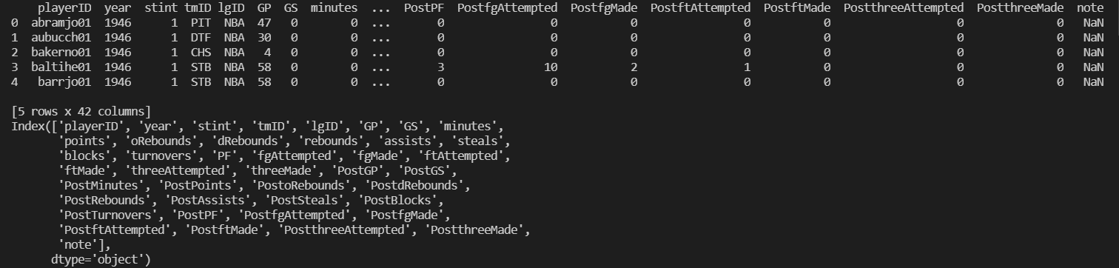

**REQUIREMENT 01.**

It finds the mean and the median of numbers of points scored.

print("Mean")

print(bestb_players.mean())

print("Median")

print(bestb_players.median())

**MEAN**

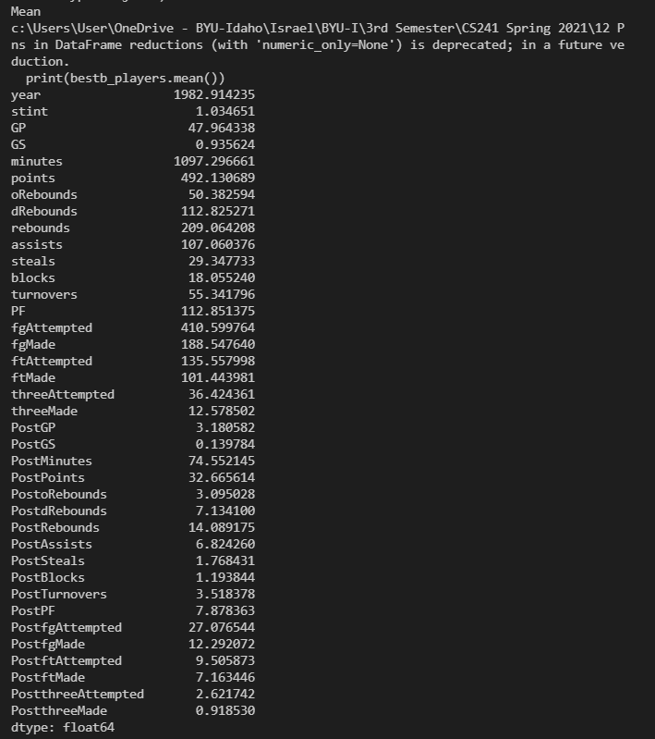

**MEDIAN**

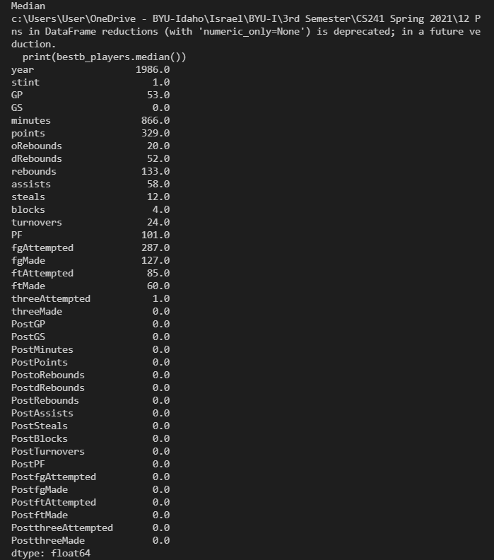

**REQUIREMENT 02.**

It finds the highest number of points per season, sorted the data by points, year and shows the highest 5.

print(bestb_players[["playerID", "year", "points"]].sort_values("points", ascending = False).head(5))

**OUTPUT**

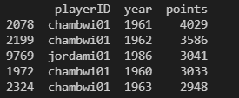

**REQUIREMENT 03.**

Produces a boxplot that shows the distribution of total points, total assists, and total rebounds.

sns.boxplot(data = bestb_players[["rebounds", "points", "assists"]])

plt.show()

**OUTPUT**

**REQUIREMENT 04.**

Produces a boxplot that shows the distribution of total points, total assists, and total rebounds.

year_nbagroup = bestb_players[["points", "year"]].groupby("year").median()

print(year_nbagroup.head())

year_nbagroup = year_nbagroup.reset_index()

print(year_nbagroup.head())

sns.scatterplot(data = year_nbagroup, x = "year", y = "points")

plt.show()

**OUTPUT**

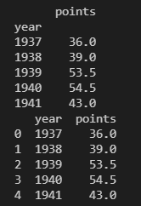**

**PART II**

To import libraries

import pandas

import pandas as pd

import seaborn as sns

import matplotlib.pyplot as plt

import numpy as np

It displays more columns

pandas.set_option("display.max_columns", 10)

**REQUIREMENT 01.**

Reads the csv file

players = pd.read_csv("basketball_players.csv")

print(players.columns)

**OUTPUT**

It creates the field goal success percent

players["fgSuccessPercent"] = players["fgMade"] / players["fgAttempted"]

It finds the players that have tried more than 0 shots

players = players[(players.fgAttempted > 0) & (players.fgSuccessPercent <= 1)]

Finds the free throw success percent

players["ftSuccessPercent"] = players["ftMade"] / players["ftAttempted"]

players = players[(players.ftAttempted > 0) & (players.ftSuccessPercent <= 1)]

Finds the three-success percent.

players["threeSuccessPercent"] = players["threeMade"] / players["threeAttempted"]

players = players[(players.threeAttempted > 0) & (players.threeSuccessPercent <= 1)]

It shows the distribution of the percentages.

sns.boxplot(data = players[["fgSuccessPercent", "ftSuccessPercent", "threeSuccessPercent"]])

plt.show()

**OUTPUT**

**REQUIREMENT 02.**

It finds players that have done more than 150 points per season

over_150 = players[(players.points > 150)]

over_150 = players[(players.ftSuccessPercent > .6) & (players.fgSuccessPercent > .6) & (players.threeSuccessPercent > .6)]

print(over_150[["playerID", "fgSuccessPercent", "ftSuccessPercent", "threeSuccessPercent", "assists", "rebounds"]])

**OUTPUT**

**REQUIREMENT 03.**

It finds the mean and median per year by leagues.

year_group = players.groupby('year')

three_stats = year_group['threeMade'].agg([np.mean, np.median])

three_stats = three_stats.reset_index()

three_stats = pd.melt(three_stats, id_vars = ["year"], var_name = "stat")

print(three_stats)

It shows the main distribution between the different leagues.

sns.relplot(data = players, x = "year", y = "threeMade", hue = "lgID")

plt.show()

It shows the trend and the distribution between the mean and median.

sns.relplot(data = three_stats, x = "year", y = "value", hue = "stat")

plt.show()

**PART III**

To import libraries

import pandas as pd

import pandas

import seaborn as sns

import matplotlib.pyplot as plt

To show more columns and read the files

pandas.set_option("display.max_columns", 10)

players = pd.read_csv("basketball_players.csv")

master = pd.read_csv("basketball_master.csv")

**REQUIREMENT 01.**

It merges the two data sets and prints the players with the highest number of points and displays the GOAT: Michael Jordan.

players = pd.merge(players, master, how="left", left_on="playerID", right_on="bioID")

print(players.columns)

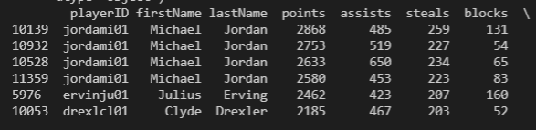

It creates the throw success percentages.

players["fgSuccessPercent"] = players["fgMade"] / players["fgAttempted"]

players = players[(players.fgAttempted > 0) & (players.fgSuccessPercent <= 1)]

players["ftSuccessPercent"] = players["ftMade"] / players["ftAttempted"]

players = players[(players.ftAttempted > 0) & (players.ftSuccessPercent <= 1)]

players["threeSuccessPercent"] = players["threeMade"] / players["threeAttempted"]

players = players[(players.threeAttempted > 0) & (players.threeSuccessPercent <= 1)]

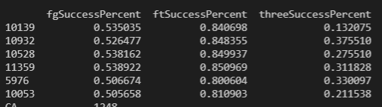

**REQUIREMENT 02.**

It finds how many players are in each state, and California has the highest number of them.

print(players["birthState"].value_counts())

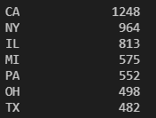

Look through California to see which city has the highest number of players.

CAcity = players[players.birthState == "CA"]

print(CAcity["birthCity"].value_counts())

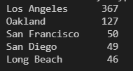

It prints the best players of Los Angeles.

LAcity = players[players.birthCity == "Los Angeles"]

print(LAcity[["firstName", "lastName", "points", "assists", "steals", "blocks", "fgSuccessPercent", "ftSuccessPercent", "threeSuccessPercent"]].sort_values("points", ascending=False))

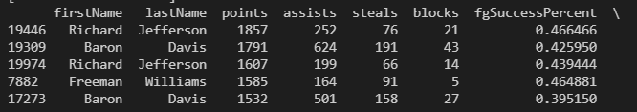

**REQUIREMENT 03.**

Shows the correlation between points with the time.

points_time = players[players.minutes >= 0]

sns.relplot(data = points_time, x = "minutes", y = "points", hue = "GP")

plt.show()

